Homework two
Ugochukwu Achara
MSBA 620

- Y=β₀​ + β₁X₁ + ε
Y = amount spent on food
X = Household income

- Scatter plot shows a moderate linear relationship with no outliers or leverage points.
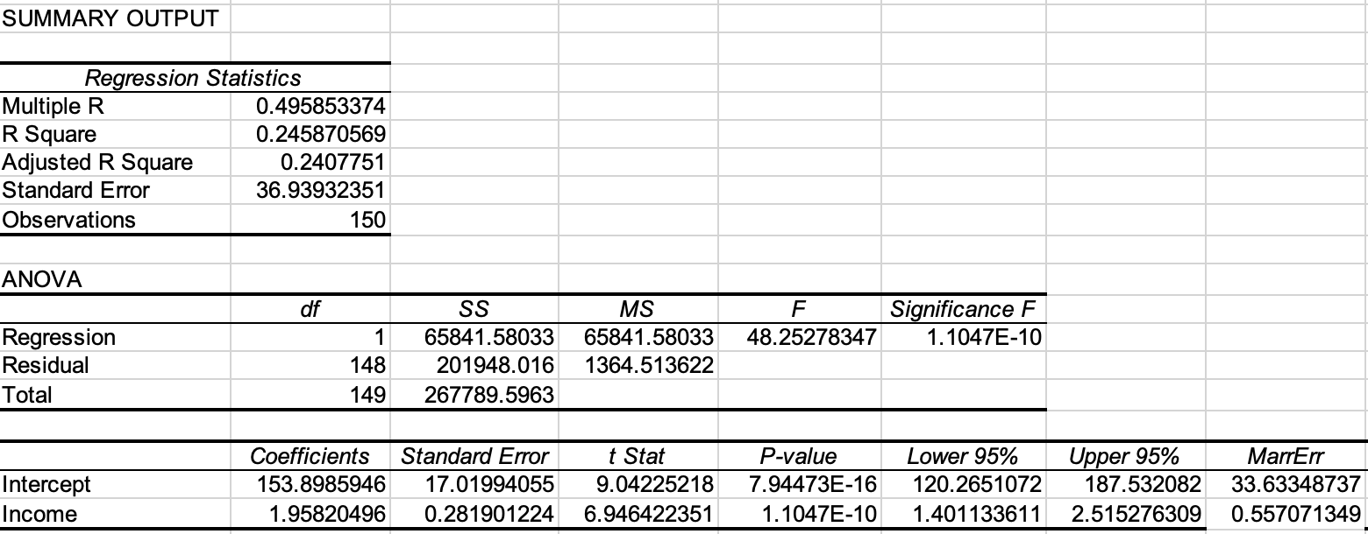
- At 95% confidence level, Anova table = 1.1 x 10⁻¹⁰ < α = 0.05. Therefore, we conclude that we have a statistically significant model. With R² = 0.245, 25% of the variation in the income* is explained by the model. The variable coefficient for food is significant.
- $\overline{x}$ = 270.26 +/- 6.83
- Est of β₁ = 1.96 +/- 0.56
- The prediction interval for the amount of money spent each week on food for a household whose annual income is $40,000 is $232 +/- $74.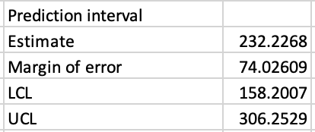

- Y=β₀​ + β₁X₁ + β₂X₂ + β₃X₃ + ε
Y = Cost of apartments
X₁ = Square footage of apartment
X₂ = Distance from downtown
X₃ = Age of apartment
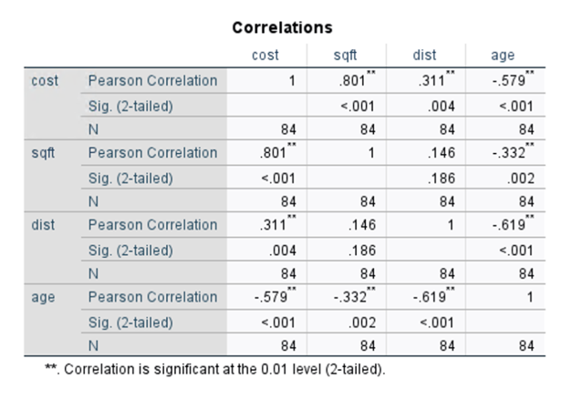
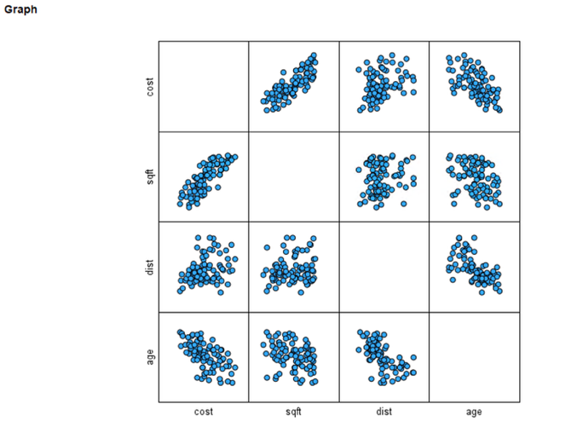
  - Yes, the data can be appropriately modeled with a linear model as evidenced by the graph and correlation matrix below. Both show that there is a linear relationship between cost and square footage (positive), cost and distance (positive) and cost and age (negative).
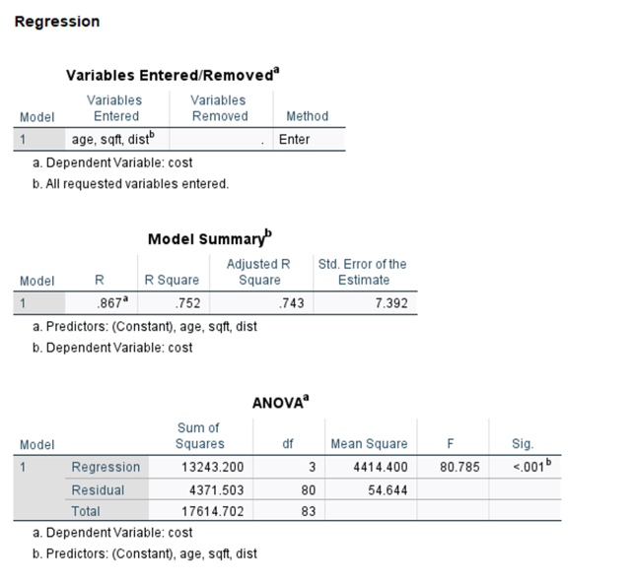

  - At 95% confidence level, ANOVA table shows that the model is statistically significant. With R² = 0.752, 75% of the variation in cost is explained by the model.

  - 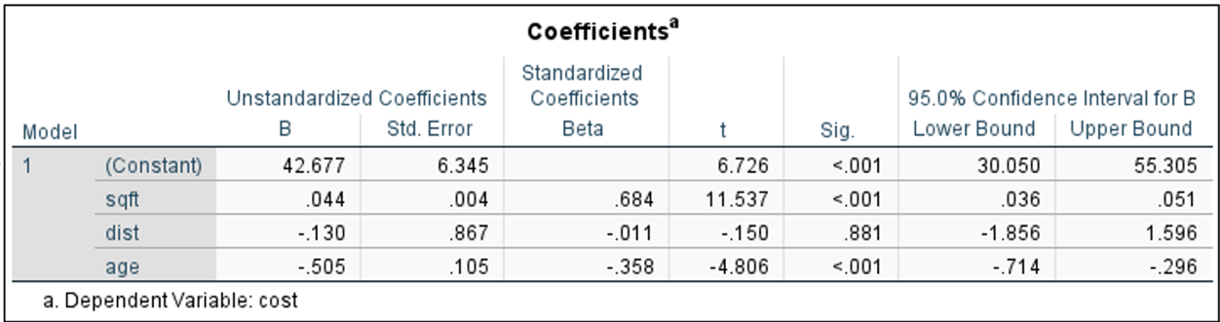β₁X₁ = 0.044 +/- 0.0075
β₂X₂ = -0.130 +/- 1.726
β₃X₃ = -0.505 +/- 0.209

β₁X₁ (square footage) and β₃X₃ (age) are statistically significant while β₂X₂ (distance) is not statistically significant.

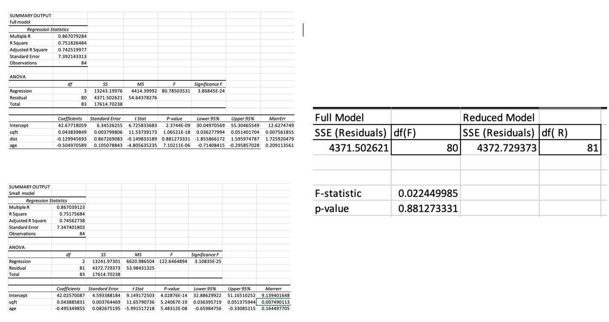
  - No since distance is not statistically significant, the best model would be a reduced model with square footage and age of apartment as they are statistically significant.
Since p-value = 0.88 > α = 0.05, we do not reject the null hypothesis of our F-test and conclude that there is no difference between the full model and the reduced model. Therefore, we would use the reduced model as any additional variable does not improve our model.

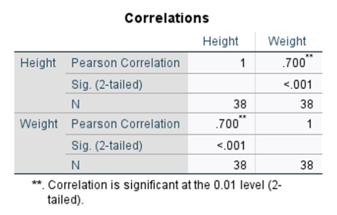
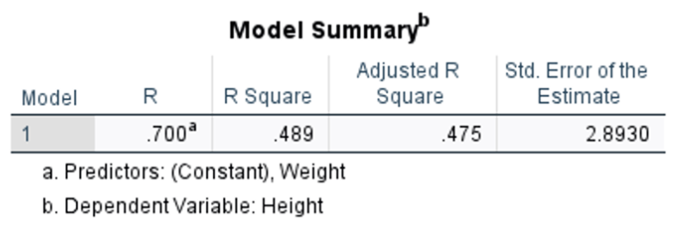
  - I would not include both height and weight in my model as the data from both are highly correlated. Height and weight have a correlation coefficient ( r ) = 0.7 and coefficient of determination (r²) = 0.489, 49% of variation in weight is explained by model. With a correlation coefficient of 0.7, the model indicates that taller people tend to weigh more with 49% of the variation in weight explained by the model with height and vice versa.
  - 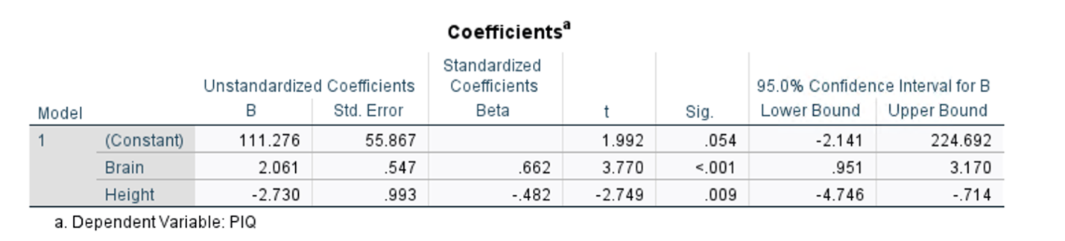

Y=β₀​ + β₁X₁ + β₂X₂ + ε
X₁ = Brain size
X₂ = Height
β₁X₁ = 2.061 +/- 0.547
β₂X₂ = -2.730 +/- 0.993

Interpretation

β₁X₁ = 2.061 +/- 0.547
Holding other variables constant, for every 10,000-count increase in brain size, there is a 2.061 increase in PIQ.

β₂X₂ = -2.730 +/- 0.993
Holding other variables constant, a one-inch increase in height, leads to a 2.730 decrease in PIQ.

